**Cancer Clinical Trials**

The Cancer Clinical Trials Unit (CCTU) in the Cancer Centre in University Hospital Limerick (UHL) coordinates a wide range of clinical trials in the cancer setting. The CCTU was established in 2001.

UHL is a designated Cancer Centre of Excellence. The CCTU facilitates all cancer clinical trials for the Midwest region.

The CCTU is involved in Medical Oncology studies for patients with Breast, Lung, Genitourinary, Gastrointestinal and Gynaecological cancers, Haematology Clinical Studies for patients with multiple myeloma, lymphomas and some leukaemia’s and Academic Studies.

The Cancer Clinical Trials Unit has recruited 64 studies since 2018 and enrolled 1195 patients.

**Clinical trials**

A clinical trial is a research study designed to test new treatments or a new way of using known treatments. The goal is to find more effective and better ways to treat or prevent cancer. A clinical trial is also known as a clinical study, research study, or medical research.

Clinical Trials may be done to test one of the following:

* New treatments
* New ways of using treatments already available
* New combinations of existing drugs
* New ways of diagnosing or preventing cancer
* The psychological effects of the treatment
* The impact of treatments on Quality of Life (QoL)

**Meet our team**

The activity of our CCTU depends on a multidisciplinary team both within the centre and within our hospital community. The CCTU is led by Prof Ruth Clifford, Consultant Haematologist and Director of CCTU and Co-director, Dr Niamh Peters, Consultant Medical Oncologist.

Our experienced CCTU team consists of the following:

* 1 Clinical Operations Manager
* 1 Clinical Nurse Manager (CNM3)
* 4 Clinical Nurse Managers (CNM2)
* 1 Clinical Trials Pharmacist
* 1 Finance & Administration Manager
* 2 Data Managers
* 1 Administration staff
* 10 Consultant Principal Investigators

**PI Team**

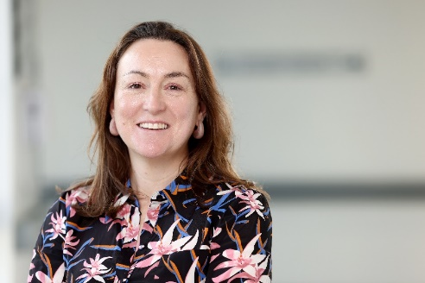

*Professor Ruth Clifford, Consultant Haematologist and Director of CCTU*

*Dr Niamh Peters, Consultant Medical Oncologist and Co-director of CCTU*



*Dr Greg Korpanty, Consultant Medical Oncologist*

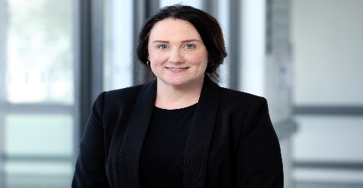

*Dr Christina Fleming, Consultant Colorectal Surgeon and Acting Co-Director of CCTU*



*Dr Cian McEllistrim, Consultant Haematologist (PI)*

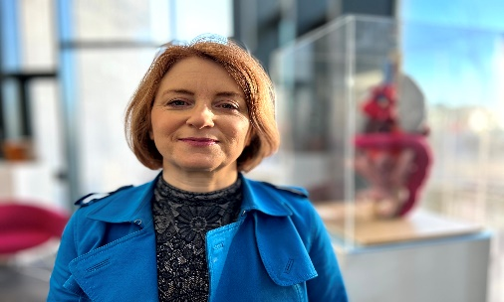

*Dr Hilary O’Leary, Consultant Haematologist (PI)*

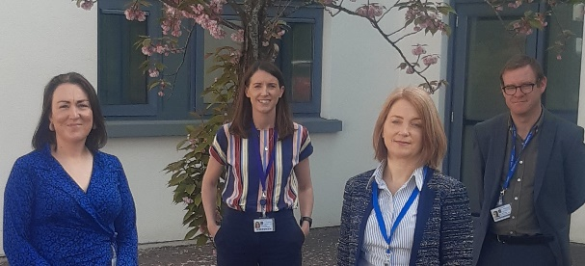

*Professor Ruth Clifford (PI), Dr Aisling Nee (PI), Dr Hilary O’Leary (PI), Dr Cian McEllistrim (PI)*

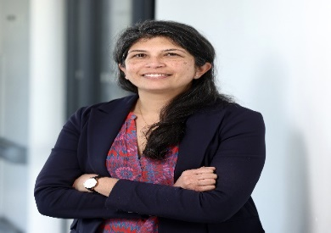

*Dr Roshni Kalachand, Consultant Medical Oncologist (PI)*

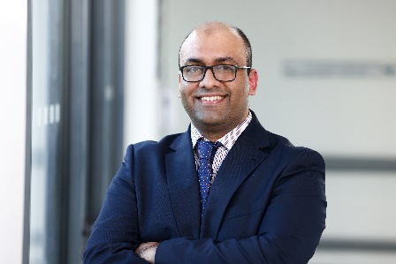

*Dr Umair Aleem, Consultant Medical Oncologist (PI)*

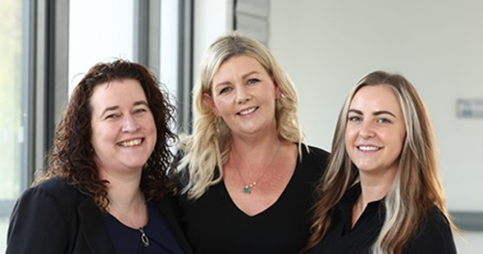

*Siobhain O’Brien, Data Manager, Michelle Meade O’Sullivan, Finance & Administration Manager, Ciara Cantrell, Data Manager*

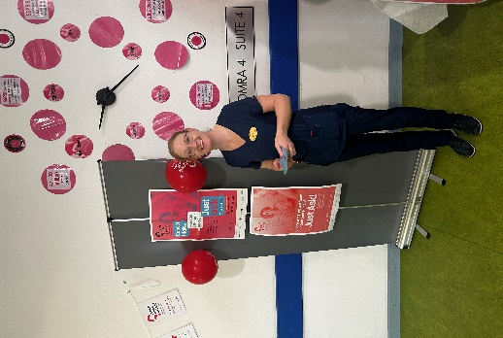

*Lorraine O’Connell, CNM3 CCTU*

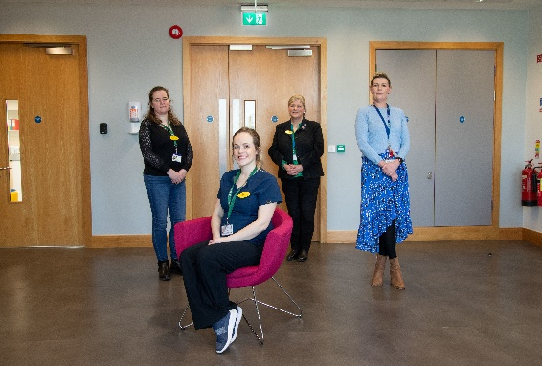

*Siobhain O’Brien, Dara Manager, Maureen O’Grady, Clinical Operations Manager, Michelle Meade O’Sullivan, Finance & Admin Manager and Michelle O’Brien, CNM3*

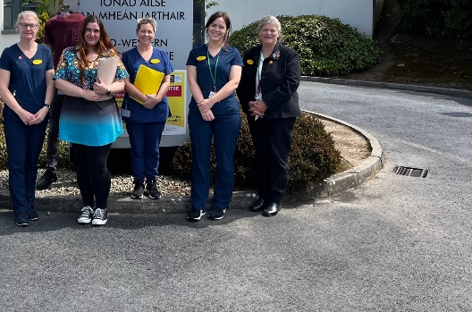

*Lorraine O’Connell, CNM3, Elzbieta Korona-Ansari, Data, Geraldine Madigan, CNM3, Clora O’Connor, CNM3, Maureen O’Grady, Clinical Operations Manager*

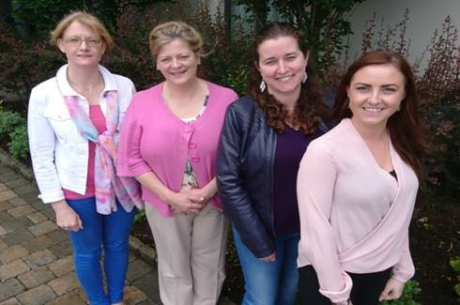

*Lorraine O’Connell, CNM3, Maureen O’Grady, Clinical Operations Manager, Siobhain O’Brien, Data Manager, Ciara Cantrell, Data Manager*

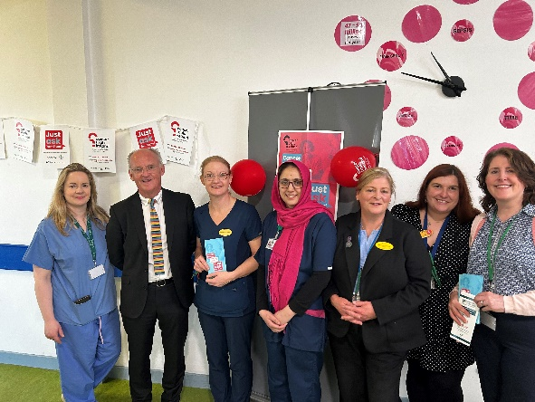

*Siobhain Egan, Cerc, Professor Declan Lyons, Head of Research, Lorraine O’Connell, CNM3, Dr Wasia Salam, Research Registrar, Maureen O’Grady, Clinical Operations Manager, Elzbieta KoronaAnsari, Administration and Deirdre Hartigan CMN3*

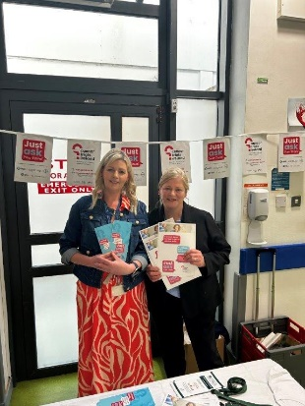

*Michelle Meade O’Sullivan, Finance & Administration Manager and Maureen O’Grady, Clinical Operations Manager*

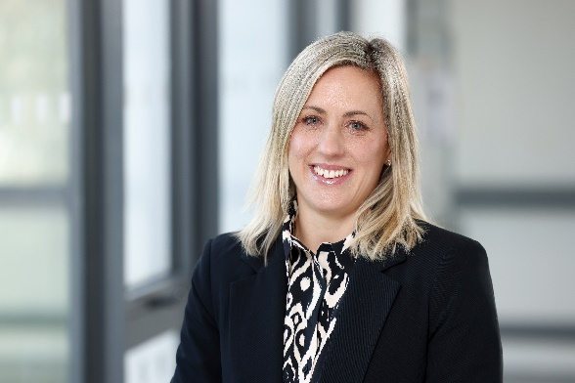

*Jennifer Hanly, Project Manager, HRB Award*

**The Clinical Trials process**

During your visit to Cancer Services at UHL, your consultant may discuss a clinical trial with you.

The research nurse (CNM2) will further explain the details of the procedures involved in participation in the clinical trial.

This will include:

* what the trial is about
* what treatment or procedures are involved
* how you will be treated
* side effects of treatment
* what you will have to do to participate in the study

The standard treatment available will also be discussed.

You will receive written information about the clinical trial to take home with you. You can discuss your options with your family or friends.

You can contact the research nurse (CNM2) with more questions during your decision making process.

If you decide to take part in a clinical trial, you have to be fully satisfied with all the information shared with you about all the procedures involved in the clinical trial.

For more information on our open clinical trials, please contact our Clinical Trials Unit.

* Email - [LCCTU@hse.ie](mailto:LCCTU@hse.ie)
* Phone: 061485159

For more information on clinical trials in Ireland see:

* [Cancer Trials Ireland](https://www.cancertrials.ie/)
* [Irish Cancer Society](https://www.cancer.ie/cancer-information-and-support/cancer-information/cancer-treatments-and-side-effects/clinical-trials)

**Current recruiting clinical trials**

**Breast**

Trial Name: **SHAMROCK**

Trial No: 2022-002485-32

Patient Profile: Patients with HER2 positive breast Cancer

Purpose: Single arm, phase II trial of neoadjuvant Trastuzumab Deruxecan (T-DXd) with response directed definitive therapy in early stage HER2 positive breast cancer; a cytoxic chemotherapy sparing approach to curative intent treatment.

Principal Investigator (PI): Dr Greg Korpanty

____

Trial Name: **ASCENT-05**

Trial No: 2024-512279-10

Patient Profile: Patients with HER2 positive breast Cancer

Purpose: A randomised, open label, phase III study of adjuvant Sacituzumab Govitecan and Pembrolizomab versus treatment of physicians choice in patients with triple negative breast cancer who have residual invasive disease after surgery and neoadjuvant therapy

PI: Dr Greg Korpanty

**Lymphoma and blood cancers**

Trial Name: **MajesTEC-4**

Trial No: 2021-002531-27

Patient Profile: Patients with multiple myeloma

Purpose: A phase III of Teclistamab in combination with Lenalidomide and Teclistamab alone versus Lenalidomide alone in newly diagnosed MM as maintenance following autologous stem cell transplant.

PI: Professor Ruth Clifford

Trial Name: **MK1026-003**

Trial No: 2020-002324-36

Patient Profile: Participants with CLL, Richet’s transformation, non-Hodgkin lymphoma and Waldenstrom’s macroglobulinaemia

Purpose: A phase II study to evaluate the safety and efficacy of ML1026-003 in participants with haematologic malignancies

PI: Professor Ruth Clifford

____

Trial Name: **ANT 007**

Trial No: 2021-003026-14

Patient Profile: Patients with cancer associated VTE (ASTER)

Purpose: A multicentre, randomized, open-label, blinded endpoint evaluation, phase 3 study comparing the effect of abelacimab relative to apixaban on venous thromboembolism (VTE) recurrence and bleeding in patients with cancer associated VTE (ASTER)

PI: Dr Cian McEllistrim

*Principal Investigator (PI): Dr Cian McEllistrim*

____

Trial name: **BCBI (Blood Cancer Biobank Ireland) sample collection**

Trial number: n/a

Patient profile: Suspected or newly diagnosed or relapsed but not on treating patients with CLL, AML or Multiple Myeloma.

Purpose: Collection of bone marrow or peripheral blood samples to be stored in a biobank for use in current or future research.

PI: Professor Ruth Clifford

____

Trial name: **The Impact of Genetic Expression Profile on Depth of Response and Survival in Myeloma (MRD Study)**

Trial number: n/a

Patient profile: Patients who have been diagnosed with multiple myeloma and are potentially eligible for autologous stem cell transplant.

Purpose: Prospective, non-interventional, observational study to evaluate the combined assessment of gene expression profiling and MRD analysis to determine impact of genetic risk on achievement of MRD negativity and PFS in newly diagnosed transplant eligible patients with Multiple Myeloma receiving standard of care regimens.

**Academic Studies**

Trial Name: **HH Blood**

Study Purpose: Blood donations of patients with hereditary haemochromatosis as a source of healthy blood cell controls

UHL PI: Professor Ruth Clifford

UL PI: Dr Elizabeth Ryan

_

Trial Name: **CLL Fantom 6**

Study Purpose: Exploring the landscape of non-coding RNA in Chronic Lymphocytic Leukaemia

UHL PI: Professor Ruth Clifford

UL PI: Dr Elizabeth Ryan

__

Trial Name: **E Health Hub**

Study Purpose: The national Cancer Strategy identified an urgent need for frameworks that increase finable, accessible, interoperable and resuable (FAIR) sharing of health data and stated it was a major obstacle in measuring performance and evidence based policy decisions.

UHL PI: Professor Ruth Clifford

UL PI: Dr Aedin Culhane

____

Trial Name: **Genomic and Immunological dysfunction in CLL**

Study Purpose: Explore Genomic and immunological dysfunction in CLL patients aggrevated by recurrent infection

UHL PI: Professor Ruth Clifford

UL PI: Dr Elizabeth Ryan

____

Trial Name: **Assessment of tx response in ABC subtype DLBCL**

Study Purpose: Improving outcomes and quality of life for patients is a priority in blood cancer research. There is a lot of variability in how patients with DLBCL respond to treatment and this can be difficult to predict in current clinical practice. The standard of care for patients with DLBCL is a monoclonal antibody in combination with chemotherapy, known as R-CHOP. Earlier identification of patients not responding to this treatment could facilitate earlier consideration for alternative treatments through clinical trials. It could also improve patient outcomes by reducing unnecessary treatment-related toxicity.

UHL PI: Professor Ruth Clifford

UL PI: Dr Elizabeth Ryan

___

Trial Name: **A comprehensive geriatric assessment in patients with a diagnosis of** **CLL or Prostate CA; a prospective cohort study of clinical and process outcomes**

Study Purpose: Comprehensive geriatric assessment in patients with a diagnosis of chronic lymphocytic leukaemia (CLL) or prostate cancer: a prospective cohort study of clinical and process outcomes

UHL PI: Professor Ruth Clifford/Dr Niamh Peters

UL PI: Dr Patrick O’Donnell/Dr Rose Galvin

___

Trial Name: **Characterisation of cellular mechanism of cancer progression and therapy resistance in metastatic and non-metastatic urological cancers**

Study Purpose: To enhance our understanding of the molecular underpinnings of various urological malignancies. The goal is to define novel biomarkers, understand disease progression and contribute to the development of more effective diagnostic and therapeutic strategies.

UHL PI: Dr Niamh Peters

UL PI: Prof Eoghan Cunnane/Dr Olwyn Mahon